What can I learn at Bee School?

Learn why bees are important to us and why we NEED them to survive.

Learn whether beekeeping is for you.

Learn what’s involved in keeping Bees from local Hobby and Commercial Beekeepers.

Learn how to analyze your hive

Learn to love a small stinging insect

When:
Friday evenings for 6 classes
beginning Feb 16, 2018 7pm-9pm
(see schedule on reverse)

Where:
South Congregational Church
27 Pleasant St.
Concord, NH (2nd floor, side door)

For more info contact us at:

capitalareabeekeepersnh@gmail.com

Bee School Registration

Name(s):

Address

City, State, Zip

Telephone_________________________

e-mail______________________________
Note: email required to receive newsletter

Please Circle:
Individual $55

Family $75 (same household, inc.2 attendees, each additional family member $10)

Course Text “Beekeeping for Dummies”
(To purchase text add $20.00)

Total included $______________

Send form and payment to:
Capital Area Beekeepers Association
Denise Hofmann
104 Poverty Plains Rd.
Warner, NH 03278

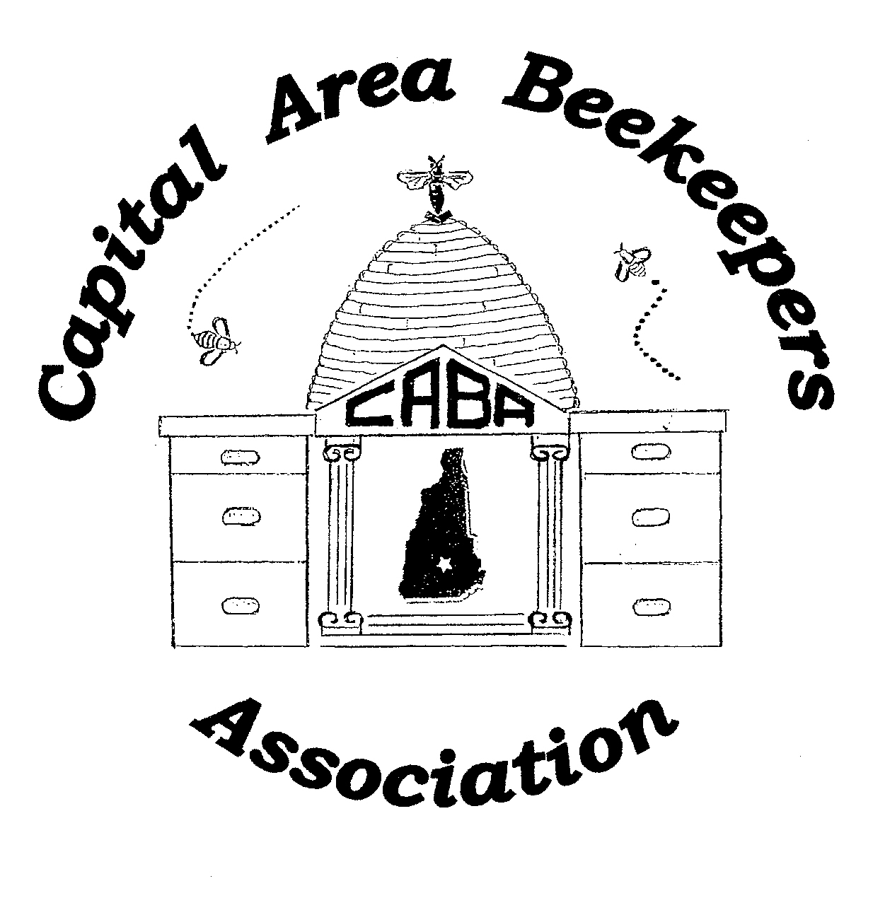

Learning is fun at the

Capital Area
Beekeepers Association
Bee School 2018

Register Online
(using PayPal)

http://capitalareabeekeepers.org/
bee-school.html

Capital Area Beekeepers Association

8th annual Bee School schedule

Classes and meetings are from
7 pm –9 pm (ish)

Class Schedule:

February 16, 2018 - Class Begins
Check in 6:30 – 6:55 pm

February 23, 2018 Second Class

March 2, 2018 - Third Class

March 9, 2018 – CABA Meeting

March 16, 2018 – Fourth Class

March 23, 2018 - Fifth Class

April 6, 2018 - Sixth Class

Live Hiving TBD (weather permitting)

Students are encouraged to attend the monthly meetings.

EXPECT:

… to learn a lot. There is so much more to successfully keeping bees than you ever imagined.

… to meet others who are equally as interested in these lovely little bugs and are also just beginning their beekeeping adventure.

…to meet long term experienced beekeepers who will be your instructors.

…to be assigned a mentor who will help you through your first year.

…to read your text and come prepared with questions.

… a varied learning experience (lecture, handouts, books, pictures, and actual equipment)

What do I bring?

You will want to have a notebook

Bring a snack to share (we will provide beverages)

CABA Membership:

As a bee school student, your first year of club membership is included in your tuition. As a member of CABA you will be part of a supportive and interactive group of beekeepers.

Membership is made up of both new and longtime beekeepers as well as professionals and hobbyists.

We strongly encourage bee school participants to attend the monthly meetings. These meetings are a great way to get to know other beekeepers and continue your beekeeping education.

One thing you learn very quickly in beekeeping, is that you never stop learning.

See you in February!

